CZRC-PA-2

Product: piwi-like RNA-mediated gene silencing 1 (CZRC Catalog ID: CZRC-PA2)
Abbreviation: Piwil1
Price: ¥1200/50ul
Isotype: IgG
Cellular Localization: Cytoplasm
Antibody type: Rabbit Polyclonal Antibody
Genecard: This gene encodes a member of the PIWI subfamily of Argonaute proteins, evolutionarily conserved proteins containing both PAZ and Piwi motifs that play important roles in stem cell self-renewal, RNA silencing, and translational regulation in diverse organisms. The encoded protein may play a role as an intrinsic regulator of the self-renewal capacity of germline and hematopoietic stem cells. Alternatively spliced transcript variants encoding different isoforms have been found for this gene. (from www.genecards.org)
Species Reactivity: Zebrafish, Chinese rare minnow, common carp, Wuchang bream
Antibody Description: This antibody can specifically label the germ cell.
Recommended Dilutions: IF: 1:200-1:1000
Size: 50 ul liquid
Phenotype:
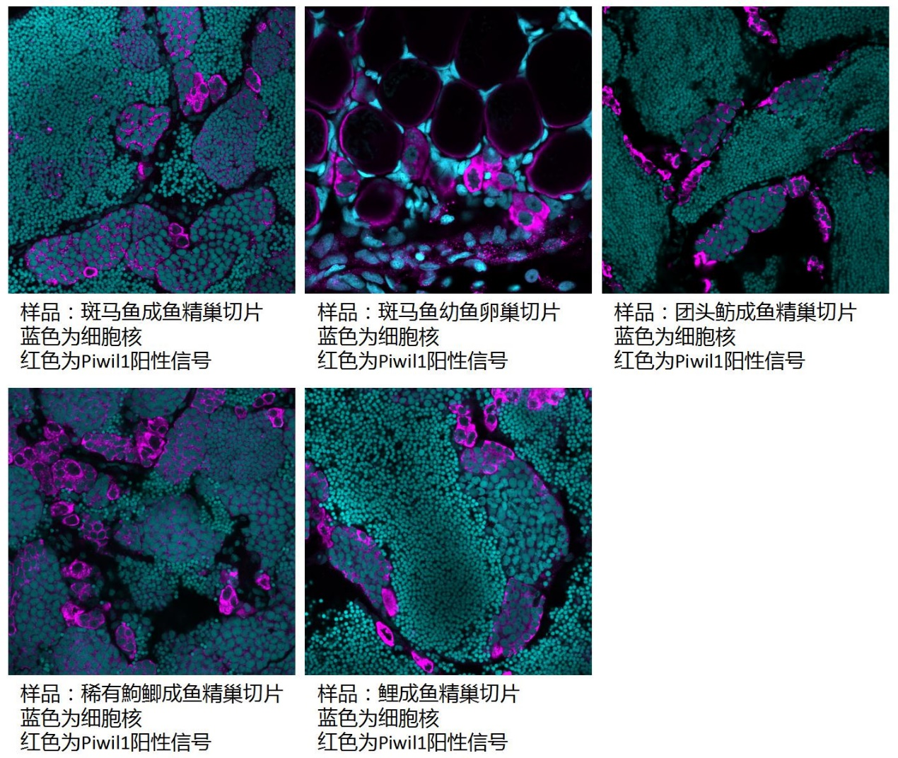
备注：由于系统更新，订购本品系时，请订购CZ500，并备注本CZRC Catalog ID号。

